**While Loop in C++**

While studying **for loop** we have seen that the number of iterations is ***known beforehand***, i.e. the number of times the loop body is needed to be executed is known to us. while loops are used in situations where **we do not know** the exact number of iterations of the loop **beforehand**. The loop execution is terminated on the basis of the test conditions.  
We have already stated that a loop mainly consists of three statements – initialization expression, test expression, and update expression. The syntax of the three loops – For, while, and do while mainly differs in the placement of these three statements.

**Syntax**:

**initialization expression;**

while (**test_expression**)

{

// statements

**update_expression;**

}

**Flow Diagram of while loop:**

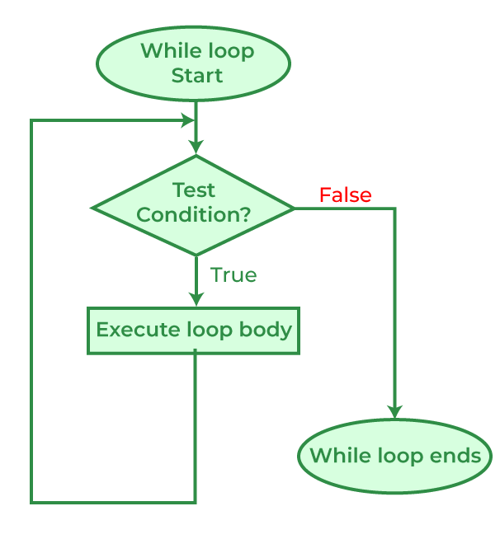

C++

// C++ program to Demonstrate while loop

#include <iostream>

using namespace std;

int main()

{

// initialization expression

int i = 1;

// test expression

while (i < 6) {

cout << "Hello World\n";

// update expression

i++;

}

return 0;

}

**Output**

Hello World

Hello World

Hello World

Hello World

Hello World